Assignment1-A
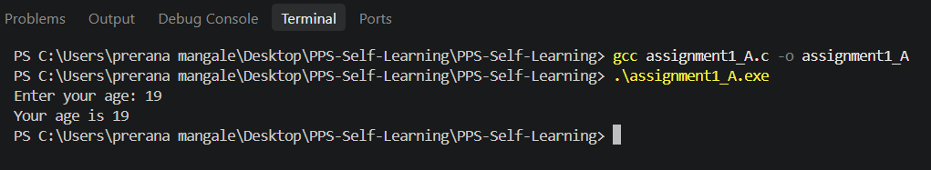

Assignment1-B
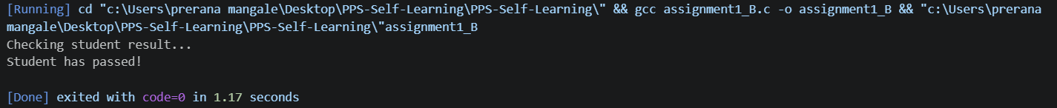

Assignment1-C
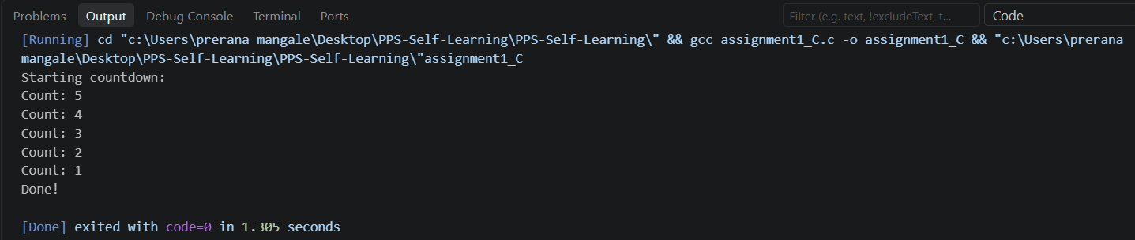
Assignment-2
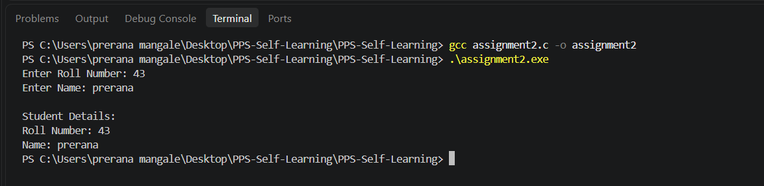

Assignment-3
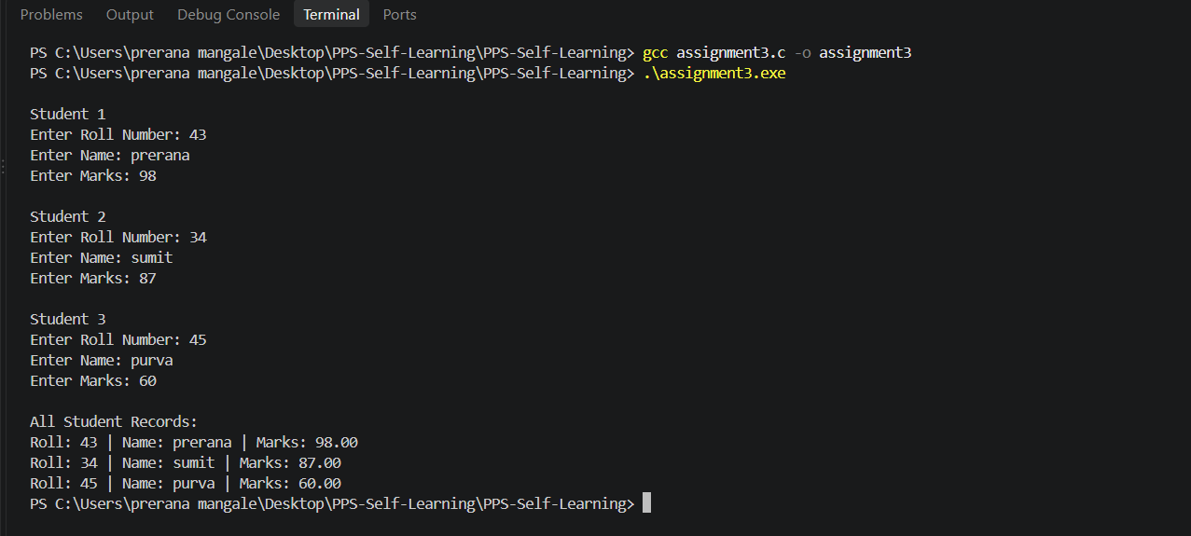

Assignment-5

